Cameras - GNC

6/19/25:

Researcher(s):
Mihika Varshney

Objective of research:
Research into usage of cameras for the ROV for better navigation

Past Team Reports

Triton Tech Robotics
- Consider a dual camera system. One for general movement while the other is for better visibility and to create more precise movements
  - Camera measurements: 61 degrees horizontal 47 degree vertical positioning
  - One faced forward, one faced towards manipulator
- Waterproofed by coating in epoxy resin and encased in acrylic cylinders
- Receptacle connectors control the camera

Camera layout
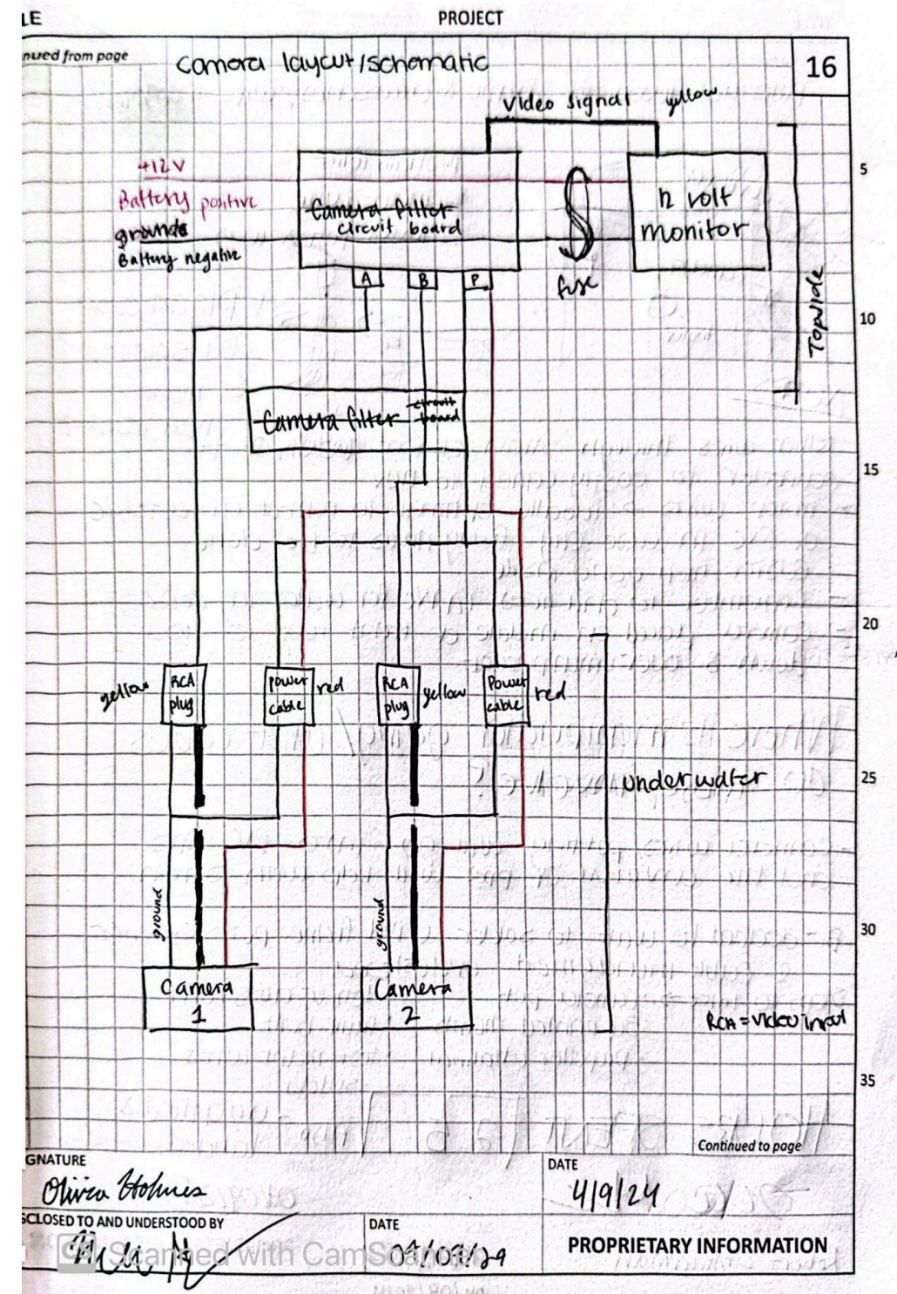

Esslingen University
- Usb camera modules: easy and cheap and can connect easily to a raspberry pi
- Epoxy resin used to waterproof camera
- 3 camera system to get an all around view of the ROV. up to 160 degree perspective

The University of Texas at Dallas Team Report
- 3-camera system: see front, underside, and claw and gripper
- Blue Robotics Low Light Camera: compact size makes them ideal
- Placed inside the main enclosure meaning not necessary to waterproof the cameras
- Created an external camera enclosure for other cameras
  - Had issues with enclosure bending due to pressure, changed from long edge feature type to radial curve with solved issue
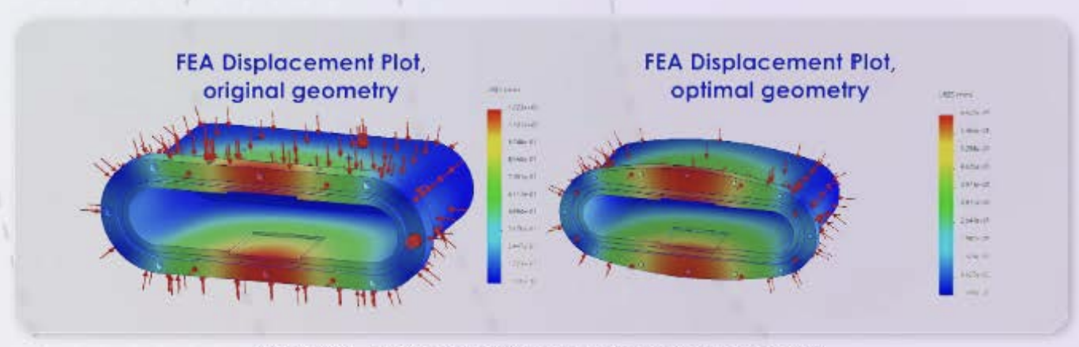

Links
- Buy a Raspberry Pi High Quality Camera – Raspberry Pi

Sources:
Triton Tech Robotics Team Report
Esslingen University Team Report
The University of Texas at Dallas Team Report

